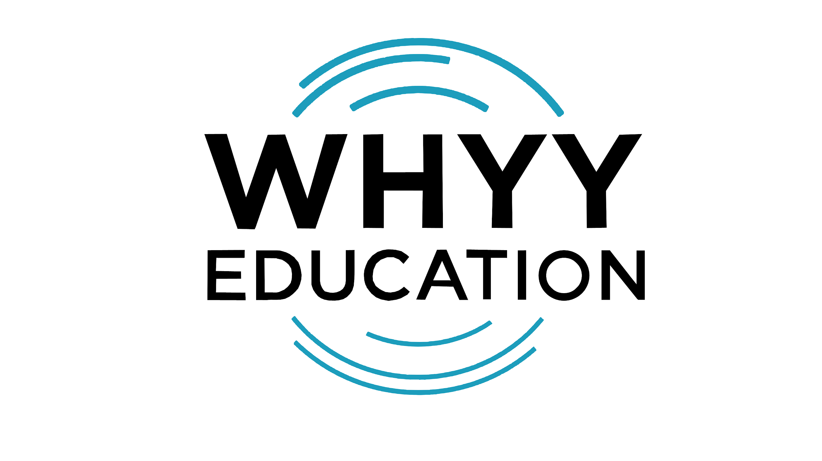
CALLING ALL STORYTELLERS AND EDUCATORS!
Do you have a skill or activity you’d like to share with students?
Want to create a short segment to post on our social media or television platforms?
Email: education@whyy.org

Your Name:

Name of your segment:

Topic:

Would this be for Instagram or TV?

Give us a brief explanation of your segment:

How would you make your segment interactive?:

What help do you need from us? Equipment troubleshooting? Editing? Brainstorming?

